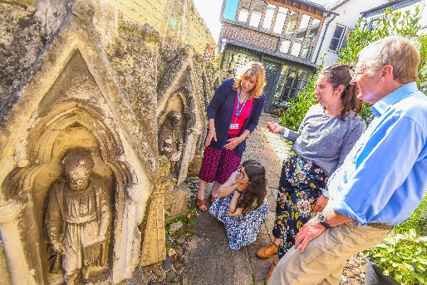

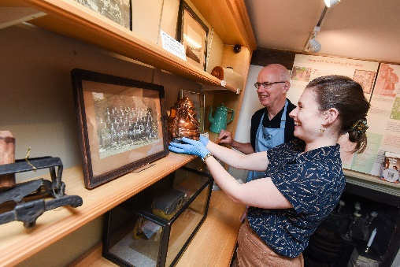
Trustee at the Museum of Cambridge
Charity no. 311309 Company no. 412205

The Museum of Cambridge is for and about Cambridgeshire, and we want to better represent the diverse Cambridgeshire communities on our Board.

We know we need to boost and broaden our Board skills and experience, and we welcome applications from individuals with skills and experience in the following areas. This could be demonstrated through your job- or volunteer-related expertise, your education and training, aspects of your lived experience, and your strong networks.

- Leadership, particularly of small charities and small businesses;
- Equity, diversity and inclusion in the arts and heritage sector and beyond;
- Fundraising;
- Business planning and development, with particular emphasis on commercial development;
- Visitor experience and/or museum curation.

It is a fantastic time to be joining the Museum of Cambridge Board because we have just launched an ambitious Strategic Plan and corresponding business plan which commits the Museum to a period of growth and diversification. As we engage with more visitors, run more events, secure more funding and grow our commercial income, we’ll need a Board of Trustees with a range of expertise to guide us.

There are currently eight Trustees who come from a variety of backgrounds. We are a friendly, supportive group, and our Board meetings (usually every three months) welcome open discussion to strengthen our governance. Most Trustees also take active ownership of a more specific role, for example, fundraising, working with volunteers, finance or more generalised roles such as helping with recruitment or trustee administration. Trustees, staff, and volunteers have regular socials, and Trustees have a shared WhatsApp group.

If, after reading this information you feel encouraged to apply to become a Trustee, please get in touch with us by emailing me, Roger Lilley, on roger.lilley@museumofcambridge.org.uk or Lucy Walker lucy.walker@museumofcambridge.org.uk for an informal chat . Or, you can go right ahead and send a cover letter and your CV.

About the Museum

The Museum of Cambridge is a unique organisation dedicated to sharing the histories of Cambridge and the surrounding areas. Set in the Grade II-listed 17th century White Horse Inn – on the important Roman road from castle to river to university – the Museum has told the extraordinary stories of ordinary people since 1936. We care for our collection of over 40,000 everyday objects that evoke the diverse daily lives of those n this region over the last 300 years.

In a city rich with museums full of priceless art and artefacts from around the world, the Museum of Cambridge is distinctive as a place for a very different kind of history: the stories of people who have lived in Cambridge and the surrounding areas that might otherwise be overlooked, silenced or forgotten.

Our Vision

We want Cambridge - and the surrounding area - to be a place where

- Everyone is able to explore, enjoy and contribute to their local histories;
- Our shared heritage is accessible, open to investigation, and preserved for generations to come;
- A creative connection with heritage inspires communities and fosters a sense of belonging.
Our Mission

Connecting communities through objects, memories and conversation.

- We take care of a unique collection of objects, photos, documents and recordings and ensure it is available to everyone;
- The Museum is a space for everyone to share their memories, be inspired by others’, and create their own;
- We are as committed to conversation as we are to conservation, and we will welcome the voices of all Cambridgeshire’s communities.

You can read more about our plans for the future in our Strategic Plan.

How to become a trustee at the Museum

We hope you will consider applying for the role of Treasurer. Applying is simple – just send an email with a CV and cover letter to roger.lilley@museumofcambridge.org.uk and lucy.Walker@museumofcambridge.org.uk. We’ll arrange an interview, online or in person, which will include questions about your skills and experience as well as offering you a chance to ask us questions too.

If you’d like to arrange a time for an informal chat with the Chair of the Board or the Director, just drop us an email and we’ll be happy to arrange a time to chat.

Role description

The Board of Trustees of the Museum of Cambridge has overall responsibility for the Charitable Company and acts as its governing body. Members of the Board of Trustees are legally responsible for directing the affairs of the organisation, ensuring that it is solvent, well run, and delivering its charitable objectives.

You can find more information about the duties of trustees on the following online resources:
- Charity Commission.
- The National Council for Voluntary Organisations.

Trustees are not paid, although reasonable expenses will be reimbursed for agreed activities. Remuneration for specific professional services may also be permitted in some instances.

All Trustees are collectively responsible for the decisions and management of the Charitable Company.

Principle Accountabilities

The Board of Trustees of the Museum of Cambridge has overall responsibility for the Charitable Company and acts as its governing body. Members of the Board of Trustees are legally responsible for directing the affairs of the organisation, ensuring that it is solvent, well run, and delivering its charitable objectives.

Trustees are not paid, although reasonable expenses will be reimbursed for agreed activities. Remuneration for specific professional services may be also be permitted in certain cases.

All Trustees are collectively responsible for the decisions and management of the Charitable Company.

As a trustee, you will:

- Provide collective leadership of the museum in support of its charitable objectives;
- Ensure that the Museum of Cambridge:
  - Complies with its Constitution, charity law and any other relevant legislation or regulations;
  - Pursues its objects as defined in its Constitution and acts within the powers defined in the Constitution;
  - Uses its resources exclusively in achieving its objects;
  - Runs effectively and efficiently and remains financially sustainable;
- Ensure that the Trust has a clear vision and strategic direction and is focused upon achieving its goals;
- Review and approve the Museum’s Business Planning
- Monitor performance and take appropriate management action to remedy variations from agreed standards;
- Ensure that all significant risks are recognised and that mitigations are put in place and monitored;
- Proactively contribute to the direction of the future activities of the Museum;
- Exercise reasonable care, skills and independent judgement;
- Act with integrity, avoid conflicts of interest and declare interest in any proposed transactions or arrangements;
- Maintain absolute confidentiality in regard to the business of the Museum of Cambridge;
- Act as an enthusiastic and well-informed ambassador for the Museum;
- Safeguard the good name and values of the Museum of Cambridge at all times.

In addition to the accountabilities that all Trustees undertake, each Trustee should use any specific skills, knowledge or experience they have to help the Board to reach sound decisions.

This may include:
- Scrutinising and contributing to the business of the Board;
- Facilitating internal or external discussions;
- Focusing on key issues or policies e.g. equality, diversity and inclusion, communications or fundraising
- Providing guidance on new initiatives, developments and services e.g. fundraising opportunities
- Contributing to and supporting short-term and permanent workgroups and sub-committees of the Board of Trustees e.g. finance or digital engagement
- Leading on other issues and activities in which the individual has special expertise or skill e.g. collection management or curation, or connecting with community groups in the area.

Person Specification

A Trustee role does not require specific educational qualifications or professional experience but there are some qualities that we do look for in a Trustee. These include:

- An interest in Cambridge and Cambridgeshire, past and present
- Lived experience of living in Cambridge and Cambridgeshire
- Knowledge of a specific area (gained in various ways such as through working, volunteering, using services and other aspects of your personal life)
- An understanding and commitment to the Museum’s values
- A commitment to attend regular Board meetings (usually 4 per year) and the Annual General Meeting (once per year)
- A commitment to working with other Trustees and staff on certain tasks e.g. sitting on one of the sub-committees, assisting staff on projects, and helping with administrative or policy-making tasks.
- The ability to Use Office 365 including Word, Excel, SharePoint and Teams. Training can be provided.

Beyond this, the Board appreciates that Trustees have different levels of time available to put into being a Trustee. Some current trustees are retired, others work full time, some have caring responsibilities and some have other personal responsibilities or pursue other charitable activities.
There is no fixed level of involvement in terms of time, but we are looking for active Trustees within their capacity, and are very happy to discuss with applicants to fit in with your other life commitments.

Trustees are asked to commit to a three-year term on the Board, with the option of serving for further terms.

There are certain legal restrictions on becoming a charity trustee, for example, you cannot be under the age of 18. Other restrictions, as well as the legal obligations of a Trustee, are outlined on the Charity Commission website. www.charity-commission.gov.uk

