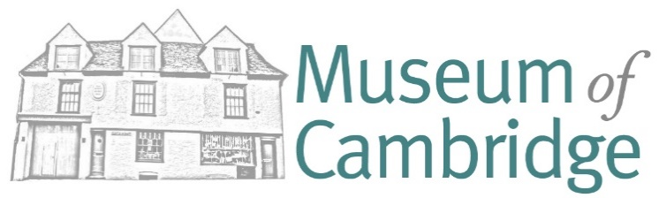
Loan box Agreement – Terms and Conditions
This box will be loaned out for a charge of £10 per week to: (school name here)
Dates: this ____ loan box is to be collected from the Museum of Cambridge on the
(start date) and returned to the Museum of Cambridge by the (end date)
Some of the items in these boxes are expensive or are not easy to replace, so please treat this resource with care.
Please show the children/adults how to handle the objects carefully and ensure that they are following your guidelines.
If playing with toys, please don’t play with them on wet, muddy or rough ground as they can be damaged.
By signing below, you are agreeing to…
- Ensure that an adult is responsible for checking and repacking the box.
- Make sure that the items are replaced in the bags or boxes that they came in.
- Use the checklist to make sure that you have returned everything.
- Make sure that all items are returned as you found them and in a clean and tidy state.
A charge may be made if extra cleaning, tidying or replacing is necessary on the return of the box.
Please sign below to say that you agree to these conditions
Signatures:
On behalf of Museum of Cambridge Alex Horn
Date
On behalf of Organisation :
Print name:
Phone Number and Email:
Date

