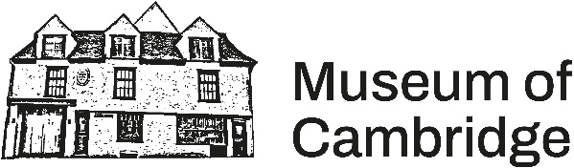
Museum of Cambridge - Booking Form and Contact Details

Your details
Your name*

Organisation or group name (if applicable)
Contact email*

Contact phone number*

*required
Event details
Date of hire*
Space required
Hire start time (includes set up)*

Hire finish time (includes clear up)*

Expected number of guests

Type of event

Anything more to tell us about your event?

Event requirements
Tea, coffee and biscuits can be provided free of charge – do you require this option? | Yes ☐  No ☐
If yes to above, do you require a refresh in the afternoon (if all day hire)? | Yes ☐  No ☐
Will you be serving alcohol at your event?  If your event will involve the sale of alcohol, you’ll need to apply for a Temporary Event Notice | Yes ☐  No ☐
Will you be arranging your own catering?  Remember, our local café Bridges offers a 5% discount and free delivery on their delicious pastries, cakes and lunch options | Yes ☐  No ☐
AV requirements | Projector ☐  Laptop ☐  Flipchart/whiteboard ☐

Accessibility, Health and Safety & Security
Does this event involve children or vulnerable adults? | Yes ☐  No ☐
Do any of your participants have specific access requirements? | Yes ☐  No ☐

Hire fee
 | Duration | Standard Rate/After 5pm | Community Rate*
Enid Porter Room and Courtyard | Hourly (2 hours minimum) | £45 | £28.75
Enid Porter Room and Courtyard | Full day or 7 hours | £280 | £180
Enid Porter Room and Courtyard | Out of hours (from 5pm) | £60 | £60

*Registered charity number (if applicable) ..................................
Total hours .......................

I have read and agree to the Terms and Conditions of Hire ☐
Signed
Print name
Date

